**WEI CHEN**

**Oct. 8th**

**Origin of data:**

**Voice of customers**

**News**

**Tasks:**

**Polarity detection: whether the expressed opinion in a document, a sentence or an entity feature/aspect is positive, negative, or neutral.**

**Emotion classification: "beyond polarity" sentiment classification looks, for instance, at emotional states such as "angry", "sad", and "happy".**

**feature-based level: determining the opinions or sentiments expressed on different features or aspects of entities.**

**semi-supervised: make use of unlabelled** [**data**](https://en.wikipedia.org/wiki/Data) **for training – typically a small amount of** [**labeled data**](https://en.wikipedia.org/wiki/Labeled_data) **with a large amount of unlabelled data.**

**Methods:**

**knowledge-based techniques, based on the presence of unambiguous affect words such as happy, sad, afraid, and bored**

**statistical methods,** [**latent semantic analysis**](https://en.wikipedia.org/wiki/Latent_semantic_analysis)**,** [**support vector machines**](https://en.wikipedia.org/wiki/Support_vector_machines)**, "**[**bag of words**](https://en.wikipedia.org/wiki/Bag_of_words)**" and *Semantic Orientation***

**hybrid approaches.**[**[**](https://en.wikipedia.org/wiki/Sentiment_analysis#cite_note-.E2.80.9CCambria-25)**both machine learning and elements from** [**knowledge representation**](https://en.wikipedia.org/wiki/Knowledge_representation) **such as** [**ontologies**](https://en.wikipedia.org/wiki/Ontologies) **and** [**semantic networks**](https://en.wikipedia.org/wiki/Semantic_network) **in order to detect semantics that are expressed in a subtle manner**

**WEI CHEN**

**Oct.15th**

**Active Deep Networks for Semi-Supervised Sentiment Classification**

<http://www.aclweb.org/anthology/C/C10/C10-2173.pdf>

* Data set:

MOV, movie reviews from IMDb. <http://www.cs.cornell.edu/people/pabo/movie-review-data/>

BOO, DVD, ELE, KIT (product reviews from Amazon)

<http://www.cs.jhu.edu/~mdredze/datasets/sentiment/>

* Model input/output:

Each review is represented as a vector of unigrams: 1 for terms present in the reviews, 0 for absent terms.

Sort the dictionary by document frequency and remove the top 1.5% (stopwords or domain specific general-purpose words).

$y∈\{-1,1\}$ (polarity detection)

* Active learning:

Initially we have L labeled training data.

for i=1 to I

Carry out the supervised learning with all labeled training data, based on active deep networks.

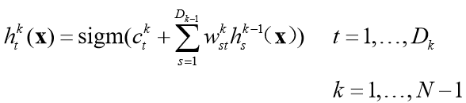

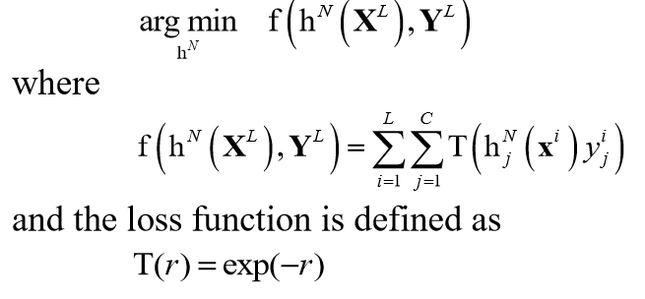

Select G unlabeled reviews that are nearest to the separating hyperplane, and label them manually. **(main idea of active learning)**

end for

**Reviews in this field**

A review paper in 2012 which introduces every recent development of sentiment analysis in detail: Cross-Domain Sentiment Classification, Cross-Language Sentiment Classification, Dealing with Conditional Sentences, Sarcastic Sentences, Aspect-based Sentiment Analysis, Sentiment Lexicon Generation, Spam Detection, etc.

<https://www.cs.uic.edu/~liub/FBS/liub-SA-and-OM-book.pdf>

Review paper in 2014, an overview of the last update during 2010-2013, including many recently proposed algorithms, enhancements and various SA applications.

<http://www.sciencedirect.com/science/article/pii/S2090447914000550>

Survey on Aspect-Level Sentiment Analysis (2016)

<https://personal.eur.nl/frasincar/papers/TKDE2016/tkde2016.pdf>

A very recent paper classifies the same movie review dataset based on feature selection (2017) that may provide the state of the art benchmark of this domain. **(around 85% for polarity detection)**

<https://www.waset.org/downloads/16/papers/17nl010049.pdf>

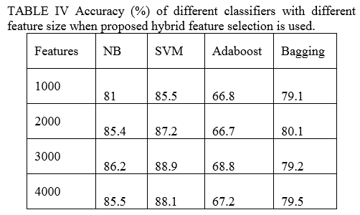

**SemEval** (**Sem**antic **Eval**uation) is an ongoing series of evaluations of computational semantic analysis systems since 2007.

This yearly evaluation focus on Sentiment Analysis in Twitter for many years.

The task 4 in 2017: **Sentiment Analysis in Twitter**

<http://alt.qcri.org/semeval2017/task4/>

Task description:

**Subtask A**. (rerun): Message Polarity Classification: Given a message, classify whether the message is of positive, negative, or neutral sentiment.

**Subtasks B-C**. (rerun): Topic-Based Message Polarity Classification:

Given a message and a topic, classify the message on

B) two-point scale: positive or negative sentiment towards that topic

C) five-point scale: sentiment conveyed by that tweet towards the topic on a five-point scale.

**Subtasks D-E**. (rerun): Tweet quantification:

Given a set of tweets about a given topic, estimate the distribution of the tweets across

D) two-point scale: the “Positive” and “Negative” classes

E) five-point scale: the five classes of a five-point scale.

Dataset: Twitter messages on a range of topics in English and Arabic.

Training data in English: <https://www.dropbox.com/s/qqvokdtalf0kgs2/2017_English_final.zip>

Survey of the submitted word for 2017: SemEval-2017 Task4: Sentiment Analysis in Twitter

<http://www.aclweb.org/anthology/S17-2088>

**WEI CHEN**

**Oct.15th**

|  |  |  |  |  |  |  |
| --- | --- | --- | --- | --- | --- | --- |
| **Dataset** | **Domain** | **Approach** | **Task** | **Level** | **Evaluation** | **Reference** |
| crawled and downloaded the first 100 reviews from Amazon & C|net.com | Product reviews | dictionary-based (P-support pruning) | Polarity | Sentence-based | Accuracy 0.79 | https://ocs.aaai.org/Papers/AAAI/2004/AAAI04-119.pdf |
| Crawled from Epinions.com  (not clear) | product reviews | unsupervised method, called Opinion Digger | 5-star rating |  | Ranking Loss: 0.49 | https://dl.acm.org/citation.cfm?id=1871739 |
| Reviews crawled tripadvisor.com or zagats.com | Restaurant and hotel reviews | lexicon-based classiﬁers | Polarity  (pos/neg) |  | precision: 68.0% / 77.2% recall: 90.7% / 86.3% | http://citeseerx.ist.psu.edu/viewdoc/download?doi=10.1.1.182.4520&rep=rep1&type=pdf |
| Chinese restaurant reviews | Restaurant reviews | unsupervised approach to aspect-based opinion polling | ternary  (pos/neg/neu)  Different level | aspect-sentiment extraction | 75.5% | https://dl.acm.org/citation.cfm?id=1646233 |
| Data crawled from the prevalent forum Web sites, including cnet.com, viewpoints.com, reevoo.com and gsmarena.com. | product reviews | SVM sentiment classiﬁer | binary | aspect-sentiment extraction | F1: 71.7%-85.1% | http://anthology.aclweb.org/P/P11/P11-1150.pdf |
| (MPQA) corpus  535 newswire documents manually annotated | newswire documents | Incorporate structural inference motivated by compositional semantics into the learning procedure. | binary | phrase-level | accuracy: 90.70% | https://www.cs.cornell.edu/home/cardie/papers/emnlp08.pdf |
| OpenTable.com  CitySearch.com  TripAdvisor hotel review | Restaurant and hotel reviews | unsupervised and weakly supervised topic modelling approaches:  Majority  LDA  MG-LDA  STM  Local LDA  SVM | 5-star rating | multi-aspect  sentence level | LAE: 0.560 - 0.790 hotel [40] reviews | http://www.myleott.com/MASA_SENTIRE2011.pdf |
| Reviews for Mp3 players from Google Product Search4 and subsets of reviews of hotels and restaurants from Google Local Search. | product, hotel, restaurant reviews | Unsupervised. Multi-grain Topic Models:  MG-LDA | binary | Aspect based  Document level | Ranking Loss: 0.669 | https://arxiv.org/pdf/0801.1063.pdf |
| reviews of five electronics products Amazon.com and C|net.com | product reviews | Unsupervised  Pattern Learning  Subclass Extraction | ternary |  | precision: 84.8% recall: 89.28% | https://ac.els-cdn.com/S0004370205000366/1-s2.0-S0004370205000366-main.pdf?_tid=55aa263e-b83b-11e7-bdba-00000aab0f27&acdnat=1508795243_692d509e9c24baf51271a4cd0e81e60b |
| reviews from epinions.com on automobiles, banks, movies, and travel destinations | product reviews | Unsupervised  PMI-IR algorithm | binary | Document level | Overall Accuracy 74.39 % correlation 0.5174 | https://arxiv.org/ftp/cs/papers/0212/0212032.pdf |
| IMDb reviews  http://www.imdb.com/reviews/index.html | Movie reviews | supervised learning  Naïve Bayes  Maximum entropy Support vector machines | binary | Document level | Best accuracy 83% | <https://arxiv.org/pdf/cs/0205070.pdf>  2002 |
| English language versions of foreign news documents from FBIS | Subjectivity classification | bootstrapping approach | Binary | Sentence based | Recall 32.9  Precision 91.3 | http://ccc.inaoep.mx/~villasen/index_archivos/cursoTATII/ClasificacionOpiniones/Riloff-ExtractionPatternsForSubjetiveExpresions03.pdf |
|  | movie reviews | hierarchical multi-classifier | three and four star rating | document-level  multi-way sentiment detection |  | https://www.researchgate.net/profile/Ingrid_Zukerman2/publication/221102026_A_Hierarchical_Classifier_Applied_to_Multi-way_Sentiment_Detection/links/00b7d51807879f1221000000.pdf |
| Amazon product review dataset  82 million product reviews | Product reviews |  |  |  | Over 92% | <https://arxiv.org/pdf/1704.01444.pdf>  from Open AI |

For supervised learning

Key: feature engineering. A large set of features have been tried by researchers. E.g., Terms frequency and different IR weighting schemes Part of speech (POS) tags Opinion words and phrases Negations Syntactic dependency, domain adaption and cross-lingual